**Aws server setup step:**

1. **Launch instance:**

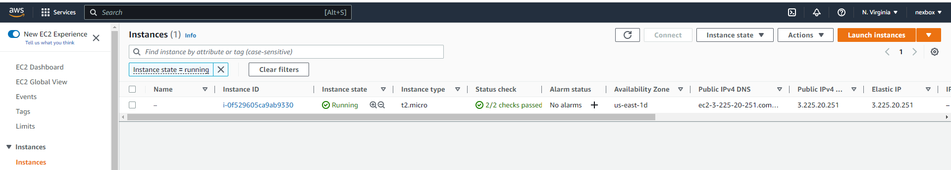

1. **Ubuntuselect:**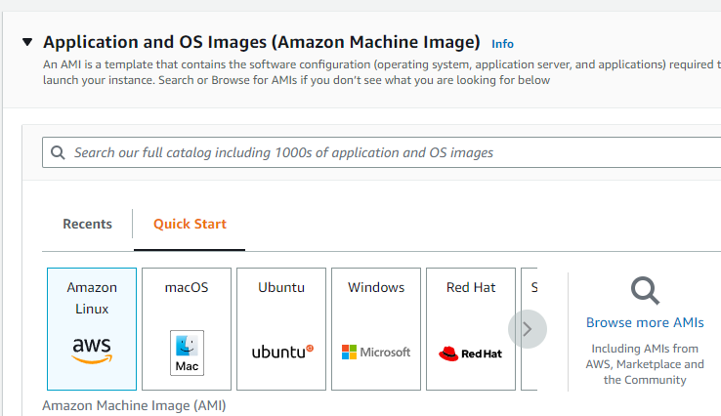
2. **version check:**

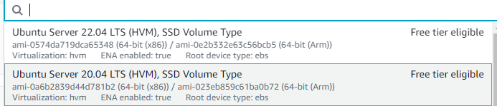

1. **Select key pair file:**

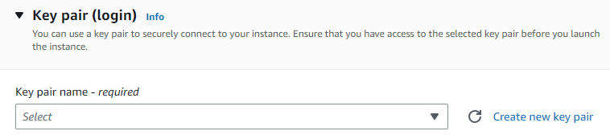

1. **Cteate key pair value:**

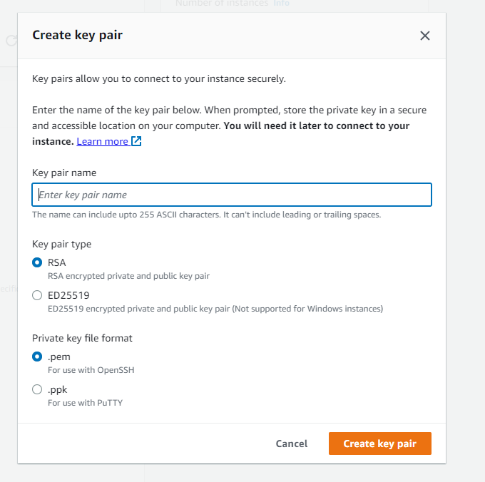

Enter key file name

1. **networking setup :**



1. **value add :**

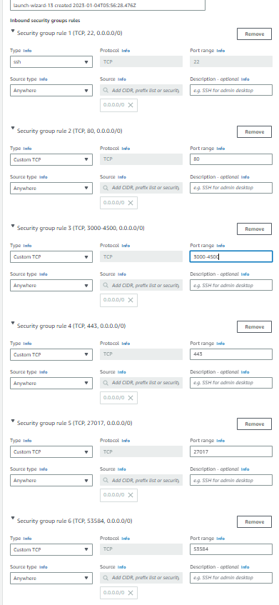

1. **Configure storage:**

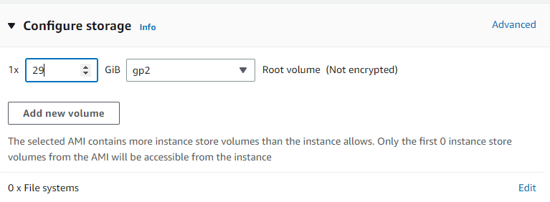

1. **And then all process compelete and launch intance button click:**

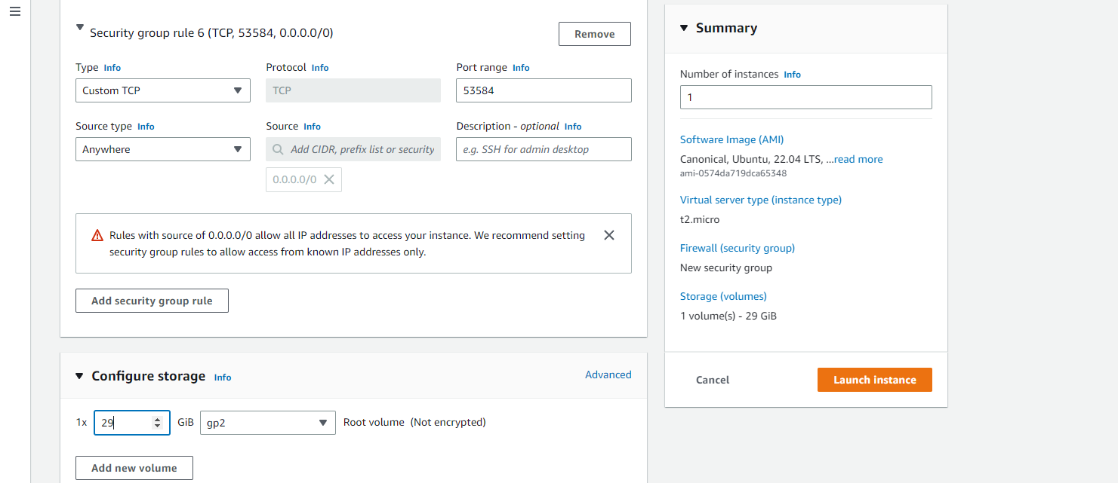

1. **Elastic ip craete:**

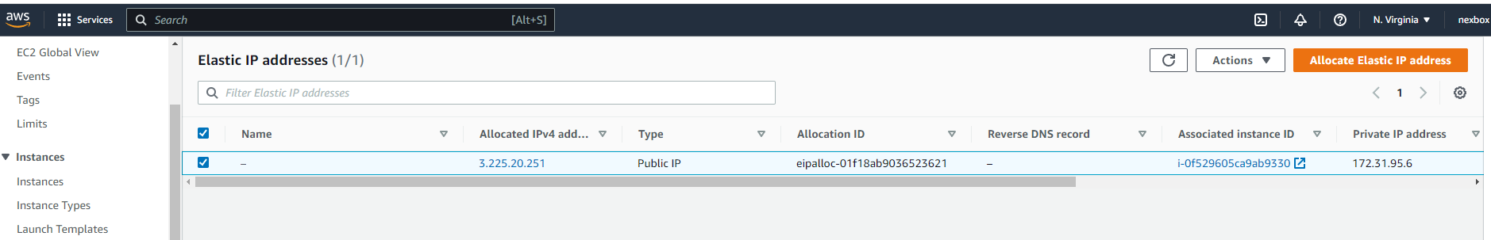

1. **Allocate ip address click and then popup open:**

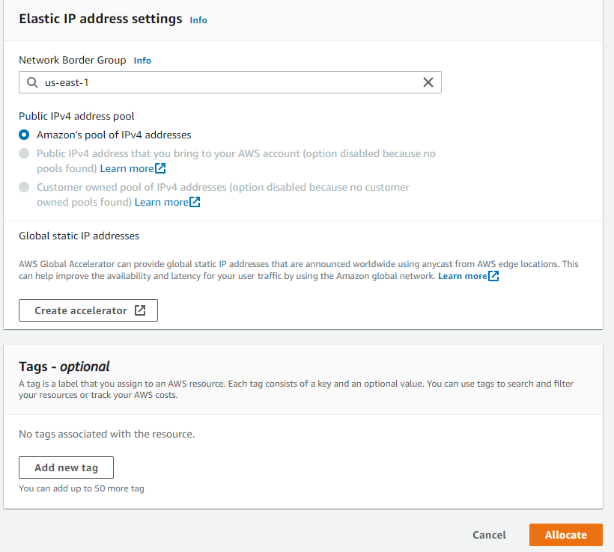

1. **Allocate button click and then elastic ip create**
2. **Istance create elasctic ip add kare**

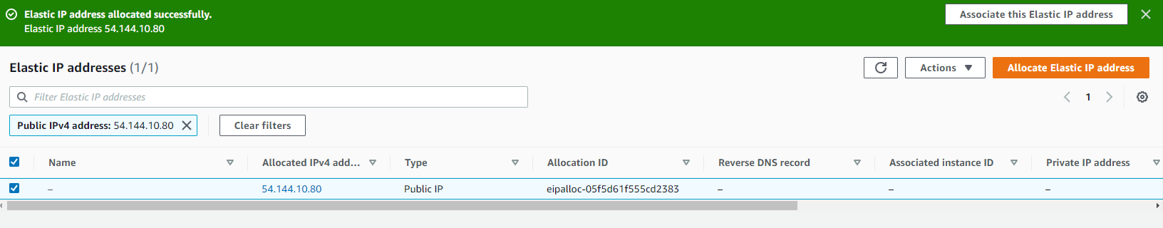

1. **Associatle elasctic ip addrses**



1. **Allocate elastic ip addresss and select elastic ip addresss and then clcik associate.**

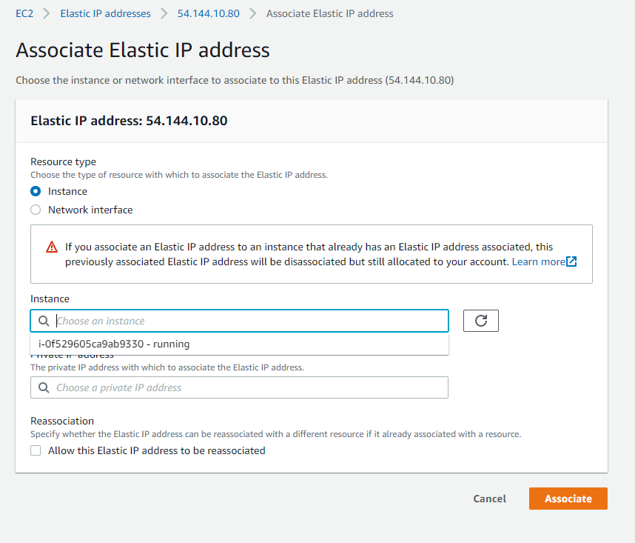

Select elasctic ip